**A INTERNSHIP REPORT ON**

# STUDY OF ARTIFICIAL INTELLIGENCE AND MACHINE LEARNING FOR TELECOMMUNICATION

submitted in partial fulfillment of the requirements for the award of the degree

of

# BACHELOR OF TECHNOLOGY

in

# MECHANICAL ENGINEERING

By

**A JAGADEESH 23751A0375**



# SREENIVASA INSTITUTE OF TECHNOLOGY AND MANAGEMENT STUDIES, CHITTOOR-517127, A.P.

**(Autonomous)**

**(Approved by AICTE & Affiliated to JNTUA, Ananthapuramu)**

# DEPARTMENT OF MECHANICAL ENGINEERING

**(2025-26)**

# SREENIVASA INSTITUTE OF TECHNOLOGY AND MANAGEMENT STUDIES, CHITTOOR-517127, A.P.

**(Autonomous – NAAC Accredited)**

**(Approved by AICTE, New Delhi & Permanently Affiliated to JNTUA, Ananthapuramu)**



**DEPARTMENT OF MECHANICAL ENGINEERING CERTIFICATE**

This is to certify that the internship report “**STUDY OF INTERNET OF THING”** is a genuine work of

**A JAGADEESH 23751A0375**

submitted to the department of Mechanical Engineering, in partial fulfillment of the requirements for the award of the degree of Bachelor of Technology in Mechanical Engineering, during the academic year 2025-26.

|  |  |
| --- | --- |
| Signature of the Supervisor | Signature of the Head of Department |
| **Mr.XXXXXXXXXXX**  Assistant Professor,  Department of XXXXXXX Engineering, Sreenivasa Institute of Technology and  Management Studies, Chittoor, A.P. | **Dr.XXXXXXXXX.,**  Professor & HOD,  Department of XXXXXXX Engineering, Sreenivasa Institute of Technology and  Management Studies, Chittoor, A.P. |

Submitted for Semester End Examination held on ……………………

**INTERNAL EXAMINER EXTERNAL EXAMINER**

**SAMPLE INTERNSHIP CERTIFICATE**

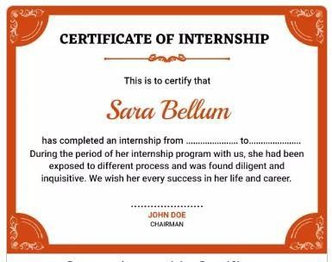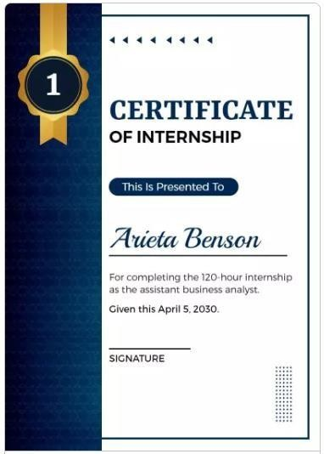

**ABSTRACT**

Air cooler is one of the appliances that keeping the atmosphere cold. The basic concept of water cooling is to find a medium that can handle and transport heat more efficient than air. Water has a very good ability to retail heat, in the meantime stay in a liquid form. This project is to design and develop a low cost air cooler which can be used in housed and office.

Secondary research has been carried out to collect data regarding the present design of air cooler. Various types of air cooler available in the market have been studied. Suppliers have been contacted and thorough understanding has been done on the merits and practical problems based on the feedbacks.

Concepts of the final air cooler have been developed and design ideas have been finalized to keep the total investment cost minimum while meeting with the requirements of the desired performance. Thus air cooler with a separate fan is selected as a the final concept through TQM concept. Colours are chosen according to its application to make it aesthetically good. The working model is finally fabricated and yielded desired results.

**INDEX**

**CHAPTER NO TABLE OF CONTENTS PAGE NO**

1. INTRODUCTION 1
   1. BACKGROUND AND MOTIVATION 1
   2. AIR COOLERS IN THE MARKET 2
   3. OBJECTIVES OF THE CURRENT PROJECT 3
2. PROJECT DESCRIPTION 23
   1. HISTORY OF AIR COOLER 23
   2. TYPES OF AIR COOLERS 23
      1. DIRECT CONTACT TYPE 24
      2. INDIRECT CONTACT TYPE 25

….

1. SUMMARY AND CONCLUSION 34

4.1

4.2

….

APPENDIX / PHOTOS 40

# CHAPTER 1 INTRODUCTION ABOUT THE COMPANY

* 1. **INTRODUCTION**

Air cooler is one of the appliances which are used to cool the air in confined space for the comfort of the occupants.

Font: *Times New Roman 12 Font Size*

# CHAPTER 2 PROJECT DESCRIPTION

**CHAPTER 3 SUMMARY AND CONCLUSON**

The entire wok of this air cooler project can be summarized as follows.

* + 1. Collection of data about existing air coolers in the market.
    2. Analysing merits and practical problems of the products
    3. Selecting the optimum model for fabrication
    4. Choosing the right type of material for each part
    5. Finding out the cost economic source of all vendors
    6. Fabrication of the mini air cooler
    7. Inspection and Testing of the final assembly
    8. Corrective action and sealing of leakages in the joints
    9. Arriving at the final project cost
    10. Demonstration of the working model.

A low cost air cooler for residential use has been made to meet the requirements of the customers. All the product design specification arrived after due considerations and final fabrication is done in a cost economic and affordable price for the consumer. The product can be utilized, which increase efficiency, comfort to profitability.

**REFERENCES**

# APPENDIX / PHOTOS